CZ4003: Computer Vision

Lab 1: Point Processing + Spatial Filtering + Frequency Filtering + Imaging Geometry

Lim Zhi Qing

U2021897L

Contents

1. Contrast Stretching 3

1.1. Intensities before Contrast Stretching 3

1.2. Subtraction and Multiplication 3

1.3. Intensities after Contrast Stretching 3

1.4. Comparison of Image Contrast 3

2. Histogram Equalization 4

2.1. Image Intensity Histogram before Equalization 4

2.2. Image Intensity Histogram after Equalization 4

2.3. Image Intensity Histogram after Second Equalization 5

3. Linear Spatial Filtering 5

3.1. Generating Gaussian Filters 5

3.2. Removing Gaussian noise 6

3.3. Removing Speckle Noise 7

4. Median Filtering 7

5. Suppressing Noise Interference Patterns 8

5.1. Power Spectrum with fftshift 8

5.2. Power Spectrum without fftshift 9

5.3. Removing peaks 9

5.4. Fourier Inverse 10

5.5. Freeing the Primate 10

6. Undoing Perspective Distortion of Planar Surface 11

# Contrast Stretching

## Intensities before Contrast Stretching

image P

min intensity: 13  
max intensity: 204

## Subtraction and Multiplication

Subtract the intensity of each pixel by the min intensity:

P2 = imsubtract(P, minP);

Multiply the intensity of each pixel:

P2 = P2 * (255 / (maxP - minP));

## Intensities after Contrast Stretching

image P2  
min intensity: 0  
max intensity: 255

## Comparison of Image Contrast

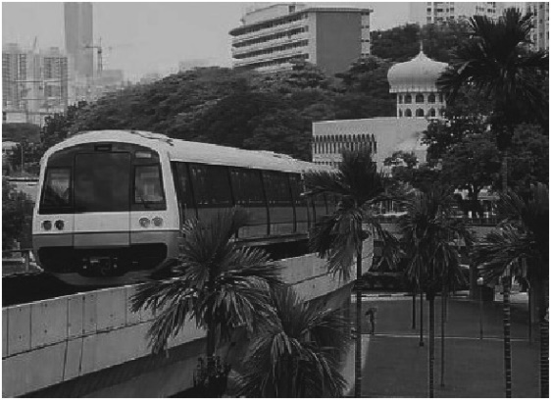 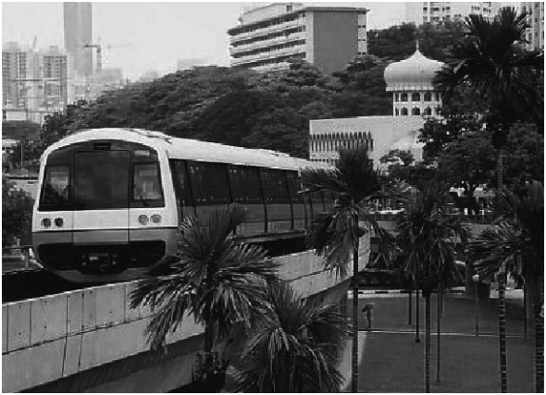

Image P Image P2

# Histogram Equalization

## Image Intensity Histogram before Equalization

Image P Histogram (10 bins) Image P Histogram (256 bins)

The histogram with 10 bins has a greater number of pixels in each bin but loses detail in comparison to the histogram with 256 bins.

## Image Intensity Histogram after Equalization

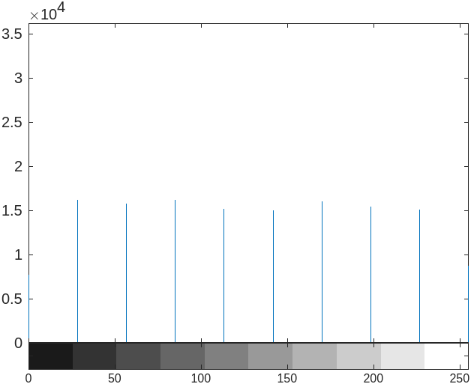 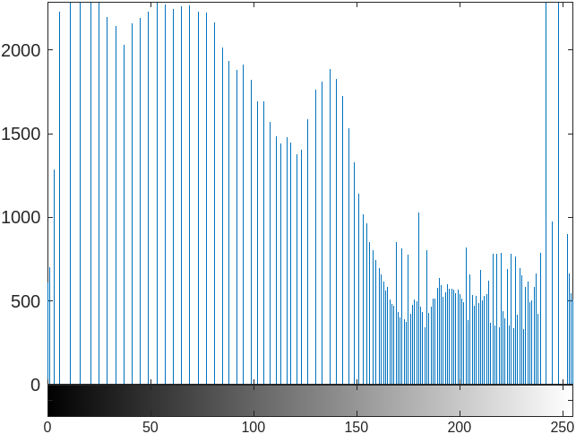

Image P3 Histogram (10 bins) Image P3 Histogram (256 bins)

The histograms for image P3 are more equalized compared to the histograms for image P.

Both histograms for image P3 are distributed across the full range of bins.

The histogram with 10 bins are well distributed across bins while the histogram with 256 bins show a cluster in the higher regions.

## Image Intensity Histogram after Second Equalization

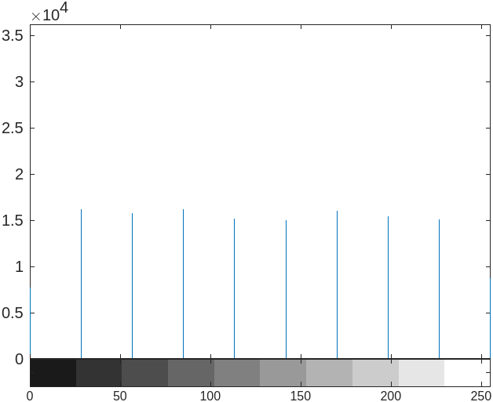 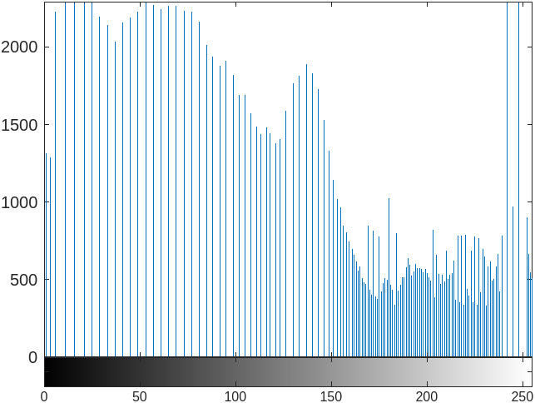

Image P4 Histogram (10 bins) Image P4 Histogram (256 bins)

The histogram does not become more uniform. The histogram has already been flattened and performing another equalization will not change the result.

# Linear Spatial Filtering

## Generating Gaussian Filters

h1 = fspecial('gaussian', 5, 1);

h2 = fspecial('gaussian', 5, 2);

h1 = 0.0030 0.0133 0.0219 0.0133 0.0030  
 0.0133 0.0596 0.0983 0.0596 0.0133  
 0.0219 0.0983 0.1621 0.0983 0.0219  
 0.0133 0.0596 0.0983 0.0596 0.0133  
 0.0030 0.0133 0.0219 0.0133 0.0030  
sum = 1.0000  
  
h2 = 0.0232 0.0338 0.0383 0.0338 0.0232  
 0.0338 0.0492 0.0558 0.0492 0.0338  
 0.0383 0.0558 0.0632 0.0558 0.0383  
 0.0338 0.0492 0.0558 0.0492 0.0338  
 0.0232 0.0338 0.0383 0.0338 0.0232  
sum = 1.0000

The sum of all elements in each filter h1 and h2 equals to 1.

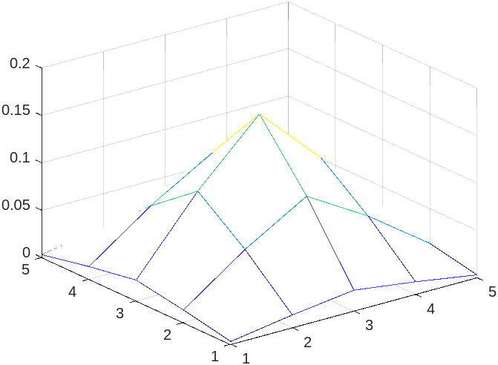 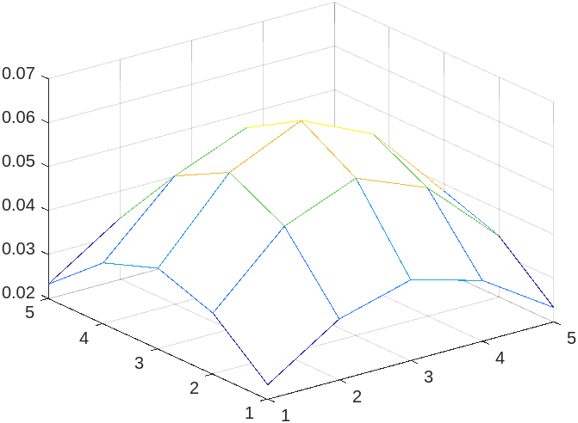

Mesh for h1 Mesh for h2

## Removing Gaussian noise

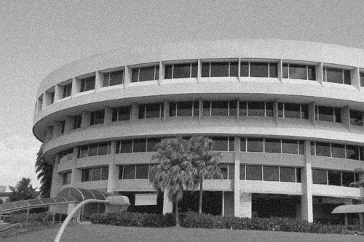

Original Image

Apply h1 and h2 to the image:

ntugn1 = uint8(conv2(ntugn, h1));

ntugn2 = uint8(conv2(ntugn, h2));

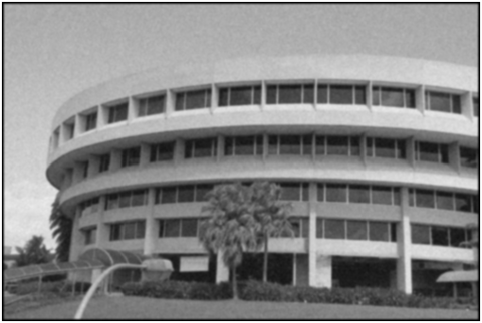 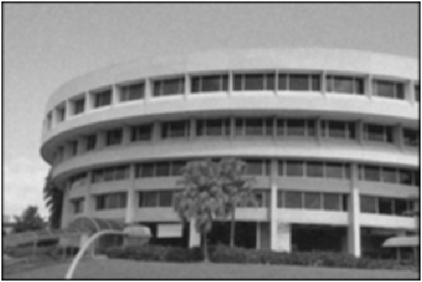

Image after h1 Image after h2

The filters are effective at removing noise. Noise is even less perceptible when higher σ is used.

Using the filters results in blurring and loss of detail. Using higher σ will cause greater blurring.

## Removing Speckle Noise

Original Image

Apply h1 and h2 to the image:

ntusp1 = uint8(conv2(ntusp, h1));

ntusp2 = uint8(conv2(ntusp, h2));

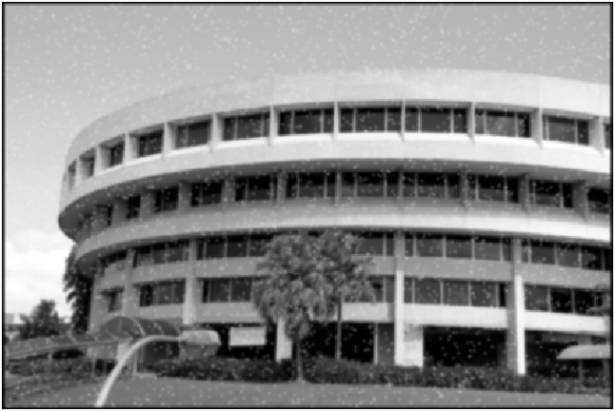 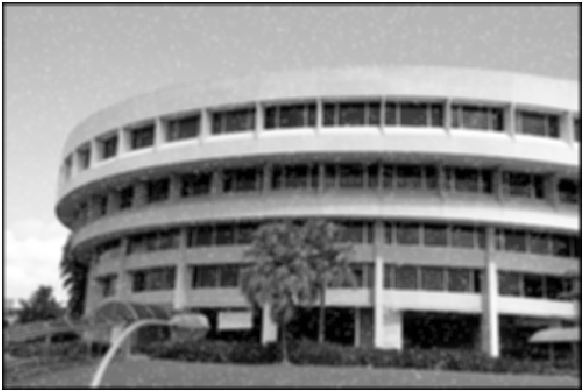

Image after h1 Image after h2

The filters are better at handling Gaussian noise than speckle noise. The speckle noise in the images after h1 and h2 are still visible.

# Median Filtering

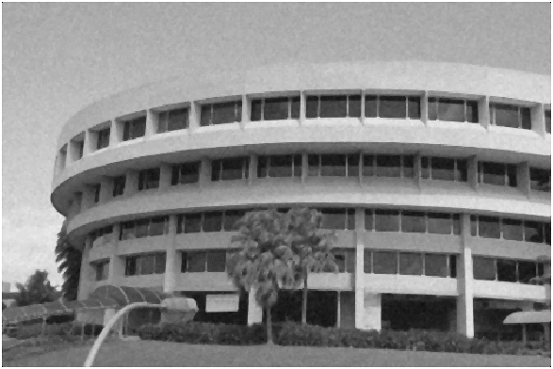 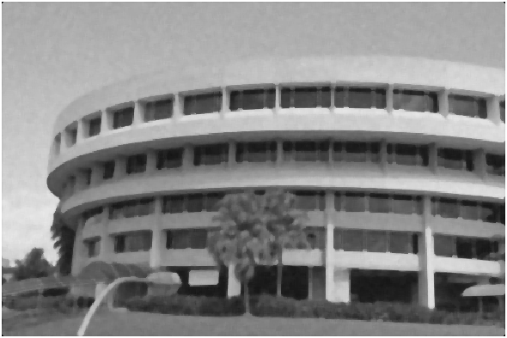

ntu-gn.jpg after median filtering 3x3 ntu-gn.jpg after median filtering 5x5

Median filtering with 3x3 neighbourhood size has a lower reduction in Gaussian noise but a sharper image than Gaussian filtering with σ = 1.

Median filtering with 5x5 neighbourhood size has a comparable reduction in Gaussian noise but a sharp loss in image detail compared to Gaussian filtering with σ = 1.

Gaussian filtering with σ = 2 has the highest reduction in Gaussian noise and better image detail than median filtering with 5x5 neighbourhood size.

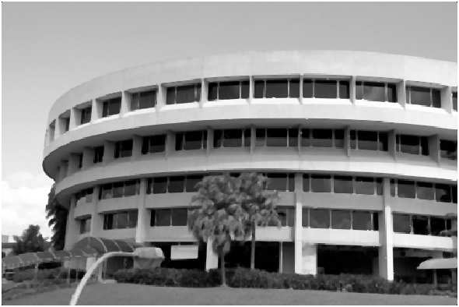 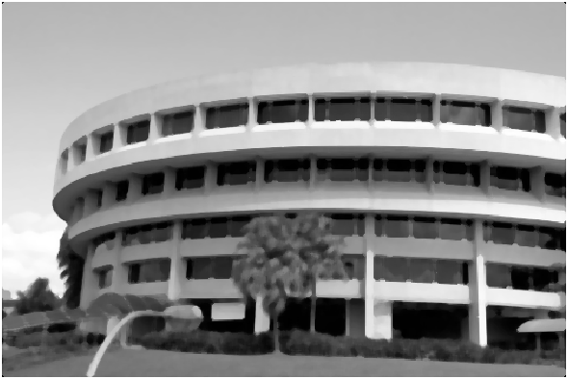

ntu-sp.jpg after median filtering 3x3 ntu-sp.jpg after median filtering 5x5

Median filtering with 3x3 or 5x5 neighbourhood size has better reduction in speckle noise than Gaussian filtering with σ = 1 or 2.

Median filtering with 3x3 neighbourhood removes speckle noise and maintains a sharp image with minimal reduction in detail.

Median filtering with 5x5 neighbourhood also removes speckle noise but has a sharp loss in image detail.

# Suppressing Noise Interference Patterns

## Power Spectrum with fftshift

Power Spectrum after fftshift

## Power Spectrum without fftshift

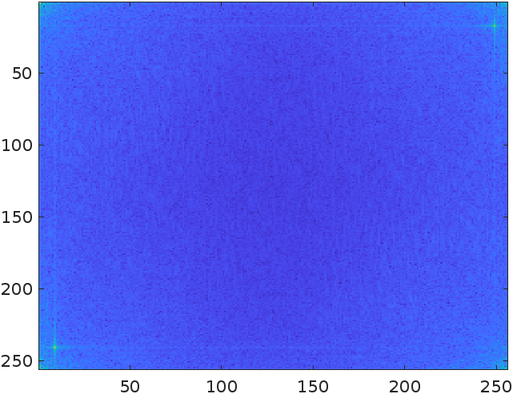

Power spectrum

Locations of peaks:

x1 = 9 x2 = 250

y1 = 240 y2 = 18

## Removing peaks

Set to zero the 5x5 neighbourhood elements at the peaks:

x1 = 240;

y1 = 9;

x2 = 18;

y2 = 250;

F(x1-2:x1+2, y1-2:y1+2) = 0;

F(x2-2:x2+2, y2-2:y2+2) = 0;

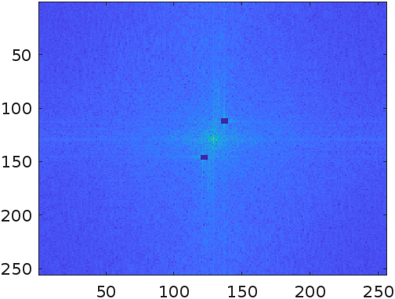

New Power Spectrum

## Fourier Inverse

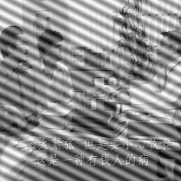 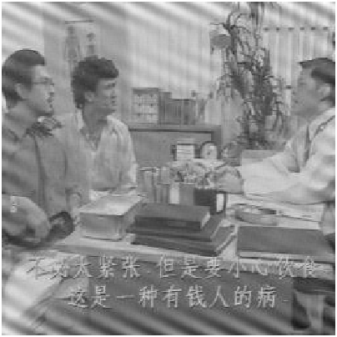

Original Image New Image

The noise is reduced especially towards the centre of the image as the 2 frequency peaks were set to 0. Increasing neighbourhood elements around the frequency peaks to set to 0 will further reduce the noise.

## Freeing the Primate

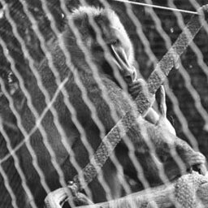 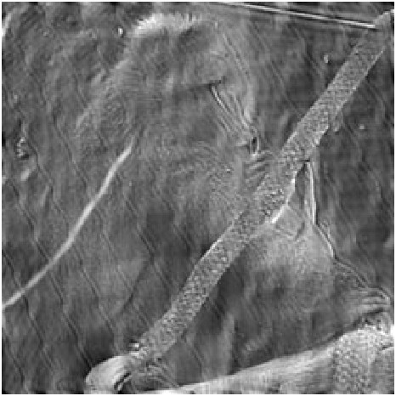

Original Image New Image

# Undoing Perspective Distortion of Planar Surface

Top left: (140, 29)

Top right: (308, 46)

Bottom left: (2, 161)

Bottom right: (258, 222)

Original Image Transformed Image

The book is no longer slanted. The bottom of the book retained similar quality while the top part of the book which was stretched is of lower quality. The resolution at the top of the book is too low to transform into readable text.